Lab 10 Report

1. **Questions:**
   1. To find the address of the watchdog timer you need to go to the include folder. This folder is inside a folder called ccs_base. The file we need to open is a file called msp430f5529.cmd. There, we can find the addresses for the registers.
   2. The intention of putting 0x4432 to R0 is to kind of make a “jump” to forward in the program. The next instruction executed is xor.b #1, &0x0202.
   3. The program ands 0x0223 with 127 to make port 4.7 0. I would guess 0x0223 is the address for P4OUT, and this code is to turn it off.
   4. Figure 14 and figure 13 may actually belong to the same microcontroller, however, I think we would need to write msp430-elf-readelf.exe -h on both files to make sure.
2. **Username and Password**

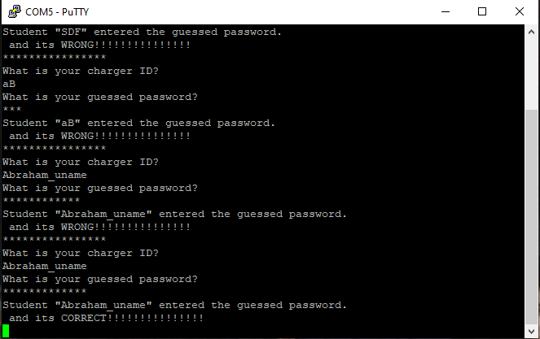

1. **File info**

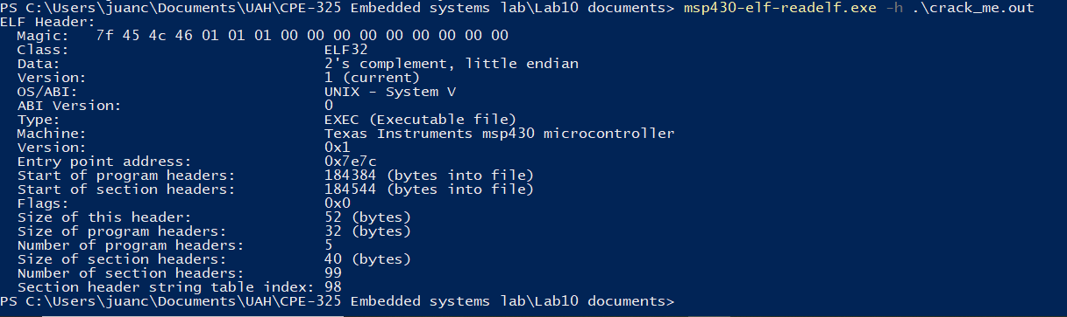

* 1. 7f 45 4c 46 01 01 01 00 00 00 00 00 00 00 00 00
  2. ELF32
  3. Texas Instruments msp430 microcontroller
  4. 52 bytes this header and 32 all others
  5. 5 program headers

1. **A picture containing diagram

   Description automatically generatedReverse me**

The board blinks two leds and when we press S3 it stops blinking and stays in that position. To restart the blinking, we just need to press S2 and then S1 in that order.

**I will show how I got the disassembly file in the demo.**